MECHTRON 3TA4 Summary

Author: Kemal Ahmed

Instructor: Dr. Mark Lawford

Date: Fall 2014

*Math objects made using* [*MathType*](http://www.dessci.com/en/products/mathtype/)*; graphs made using* [*Winplot*](http://math.exeter.edu/rparris/winplot.html)*.*

Please join GitHub and contribute to this document. There is a guide on how to do this on my GitHub.

Table of Contents

Chapter 1 1

Design Metrics 1

Chapter 2 2

Datapath 2

Op-Amps 2

Filters 4

Stepper Motors 4

# Chapter 1

**Market Window (W)**: the amount of time, in months, between the on-time entry of the company and peak revenue. It is also the amount of time from peak revenue to when revenue gets to 0. In other words, the entire lifecycle of a product is 2×W

**Delay (D)**: the entry point of a company given a delay

Revenue loss depending on entry = 

Percentage revenue loss = 

## Design Metrics

**Non-Recurring Engineering (NRE) cost**: one-time cost to design a system. No more design costs are needed

**Unit cost**: cost of manufacturing one instance of design

# Chapter 2

## Datapath

1. Identifying variables
2. Identifying operations

State machine data-path symbols:

* Register: 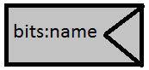
* Multiplexor: 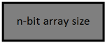
* Operations: regular white rectangles

# Op-Amps

**Operational Amplifiers**:

* outputs attempt to do whatever is necessary to make the voltage difference between the inputs zero
* inputs draw 0 current

**Ideal characteristics of op-amps**:

1. Infinite voltage gain
2. Infinite input impedance
3. Zero output impedance
4. Infinite bandwidth
5. Zero input offset voltage (i.e., exactly zero out if zero in).

**Slew rate** [SR]: maximum rate of change of voltage / s



*vout = vo*

*vin = vi*

**Gain** [*K*]: 

**Differential Mode Gain** [*Kd*]: 

**Common Mode Gain** [*Kcm*]: 

**Pull up resistor**: When the switch is open, the pull-up resistor brings the voltage up, while when it’s closed, *v* goes to ground

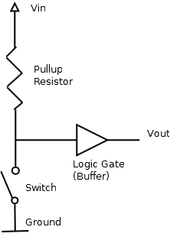

**Pull down resistor**:

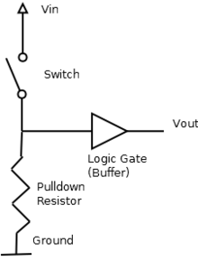

**Pulse-Width Modulation (PWM)**: a technique for getting analog results with digital means

e.g. To create a 3V signal given a digital source that can be either high (on) at 5V or low (off) at 0V, you can use PWM with a duty cycle of 60% which outputs 5V 60% of the time. If the digital signal is cycled fast enough, then the voltage seen at the output appears to be the average voltage

**Transfer function**: [*G*(*s*)] a function that represents what the system does to the voltage



Units: V/mV (to reduce the number of 0’s

**Common Mode Rejection Ratio (CMRR)**: measured in dB



**Actuator**:

**Input impedance**: impedance of input lead(s)

**Output impedance**: impedance of output lead(s)

**Angular Resolution**: 

[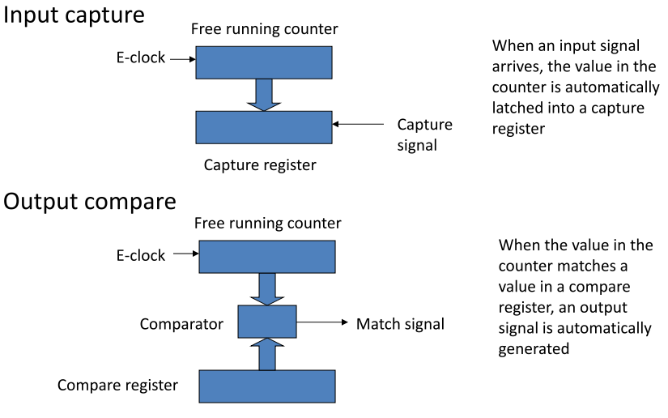](http://eecs.mines.edu/Courses/eggn482/lectures/26-OutputCompare.pdf)

When the counter gets to the time held in the compare register, the comparator sends a match signal, sparking an event.

## Filters

Orders: the order of the gain formula

Band pass: only allows middle of hill

[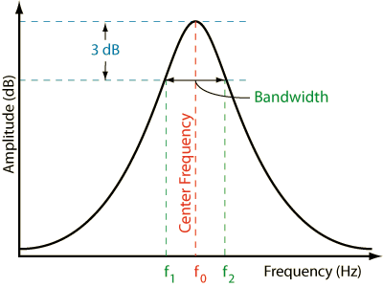](http://www.rane.com/n170fig1.gif)

Notch: allows everything except perfect frequency

[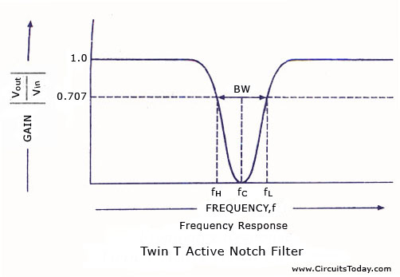](http://www.circuitstoday.com/wp-content/uploads/2009/10/Frequency-Response-Twin-t-active-notch-filter.jpg)

# Stepper Motors

**DC Motors**: not stepper motors… finish this!!!!!!!!!!!!!!

[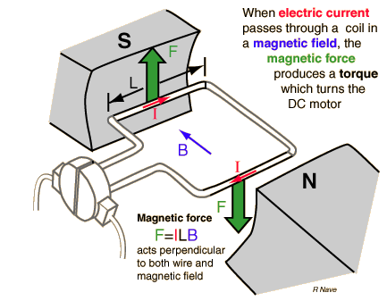](http://hyperphysics.phy-astr.gsu.edu/hbase/magnetic/imgmag/dcmfor.gif)

**Brushes**:

[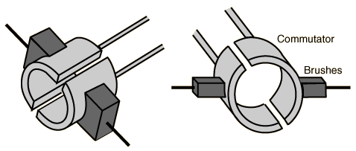](http://hyperphysics.phy-astr.gsu.edu/hbase/magnetic/imgmag/comtat.gif)

**Stepper motor**: brushless, AC motors

**Poles**: Most magnets have 2 poles, but a magnet in the shape of an asterisk (*) has 6 poles

* maintains number of wires
* increased resolution
* higher magnet cost

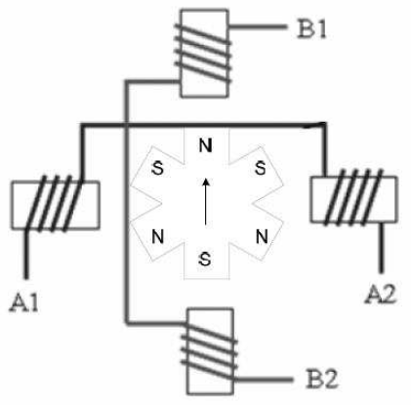

**Phases**: number of windings (the cork-looking thingys)

* more windings, more wires

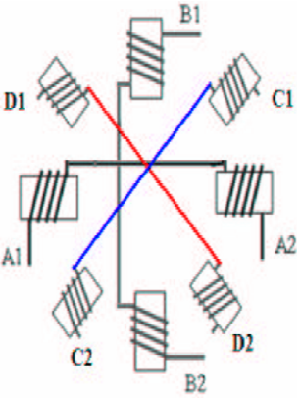

**Angular resolution**:, *n* = number of phases

**Half-stepping**: alternating between 2 phase and single phase; reduces torque, but increases speed

 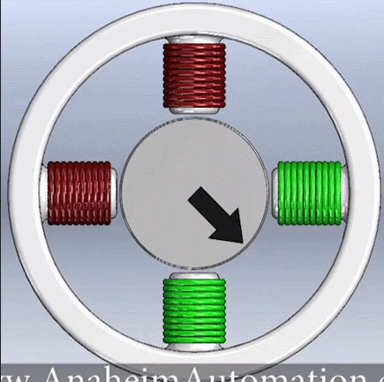

**Micro-stepping**: take the half-step model, but vary the current levels in the magnets to make tinier steps

<http://en.nanotec.com/support/tutorials/stepper-motor-and-bldc-motors-animation/>

**Magnetic Reluctance**: resistance, but of magnetic fields, not electric fields

**Switched Reluctance Motor (SRM)**: non-permanent magnets

* low cost
* coils in the middle stay the same, magnets on outside rotate
* Need odd number of teeth
* 

